**Day 3 – E-Mail Service**

1. Research the following internet protocols related to e-mail services.
   1. SMTP Protocol
   2. POP3 Protocol
   3. IMAP Protocol
   4. Web Mail
2. Use the following resource as a starting point:  
   <https://askleo.com/what_is_pop_or_pop3_or_a_pop_account_and_what_about_smtp/>
3. Complete the following Venn Diagram to summarize your research.

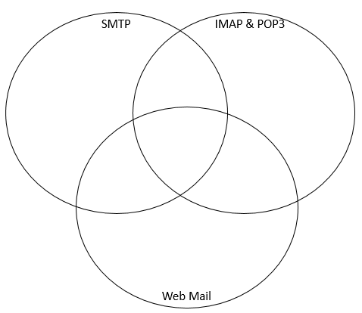

-Both STMP and POP3 transfers a email to a computer

-Web mail is web based email accounts such as Hotmail, Gmail, and Yahoo mail

-Web mail lets users access their emails as long if they have internet connection and a web browser

-IMAP leaves a master copy of the email on the server for emails, so It basically lets you look at the master copy from another device

-POP3 downloads your email on the computer that is being used

-STMP is the protocol that transfers a email to another email